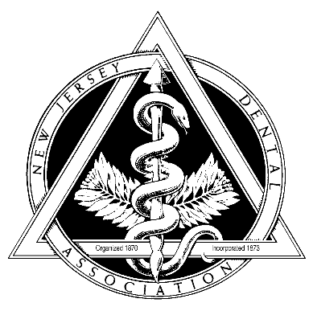

Middlesex County Dental Society

P.O. Box 7026 East Brunswick NJ 08816

MCDS Phone: (732) 238-1255 MCDS Fax: (732) 390-2332

